WEEK 7 - REACT (CONT.)

TASK - 9

src/Components/ListOfPlayers.js
import React from 'react';
function ListOfPlayers({ players }) {
return (
<div>
<h2>All Cricket Players</h2>
<ul>
{players.map((player, index) => (
<li key={index}>
{player.name} - Score: {player.score}
</li>
))}
</ul>
</div>
);
}
export default ListOfPlayers;

📄 src/Components/IndianPlayers.js
import React from 'react';
function IndianPlayers({ players }) {
const filtered = players.filter(player => player.score < 70);
return (
<div>
<h2>Indian Players (Score &lt; 70)</h2>
<ul>
{filtered.map((player, index) => (
<li key={index}>
{player.name} - Score: {player.score}
</li>
))}
</ul>
</div>
);
}
export default IndianPlayers;

📄 src/App.js
import React from 'react';import ListOfPlayers from './Components/ListOfPlayers';import IndianPlayers from './Components/IndianPlayers';
function App() {
const T20Players = [
{ name: 'Virat Kohli', score: 85 },
{ name: 'Rohit Sharma', score: 95 },
{ name: 'Hardik Pandya', score: 45 }
];

const RanjiTrophyPlayers = [
{ name: 'Shubman Gill', score: 68 },
{ name: 'Ruturaj Gaikwad', score: 72 },
{ name: 'Sarfaraz Khan', score: 61 }
];

// 1. Merge arrays
const allPlayers = [...T20Players, ...RanjiTrophyPlayers];

// 2. Add more to make it 11 players
const extraPlayers = [
{ name: 'MS Dhoni', score: 70 },
{ name: 'R Ashwin', score: 30 },
{ name: 'Bumrah', score: 60 },
{ name: 'KL Rahul', score: 74 },
{ name: 'Ishan Kishan', score: 25 },
];

const completeTeam = [...allPlayers, ...extraPlayers];

// 3. Flag for conditional rendering
const showAll = true;

// 4. Destructuring example: odd vs even index players
const oddPlayers = completeTeam.filter((_, i) => i % 2 !== 0);
const evenPlayers = completeTeam.filter((_, i) => i % 2 === 0);

return (
<div style={{ padding: '20px', fontFamily: 'Arial' }}>
<h1>🏏 Cricket Player App</h1>
<hr />
{showAll ? (
<ListOfPlayers players={completeTeam} />
) : (
<IndianPlayers players={completeTeam} />
)}

<hr />
<h2>Players at Even Positions</h2>
<ul>
{evenPlayers.map((player, i) => (
<li key={i}>{player.name}</li>
))}
</ul>

<h2>Players at Odd Positions</h2>
<ul>
{oddPlayers.map((player, i) => (
<li key={i}>{player.name}</li>
))}
</ul>
</div>
);
}
export default App;

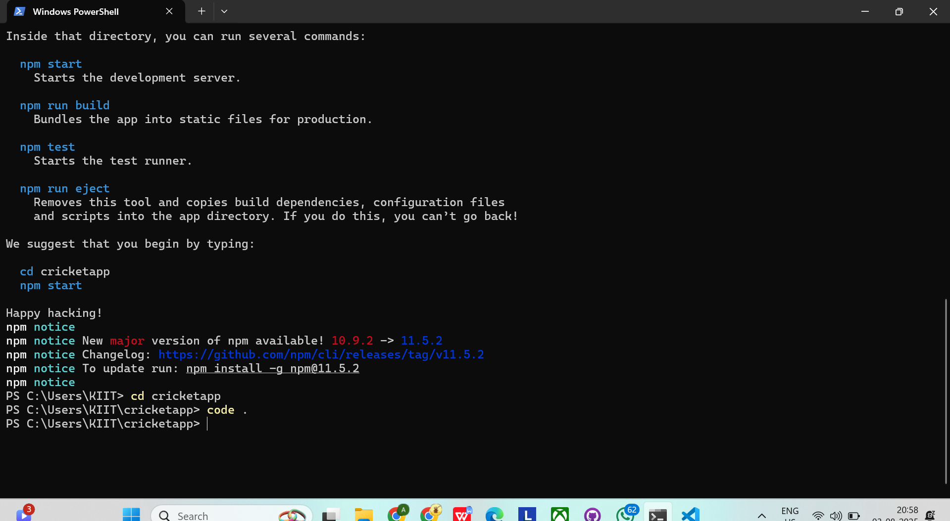
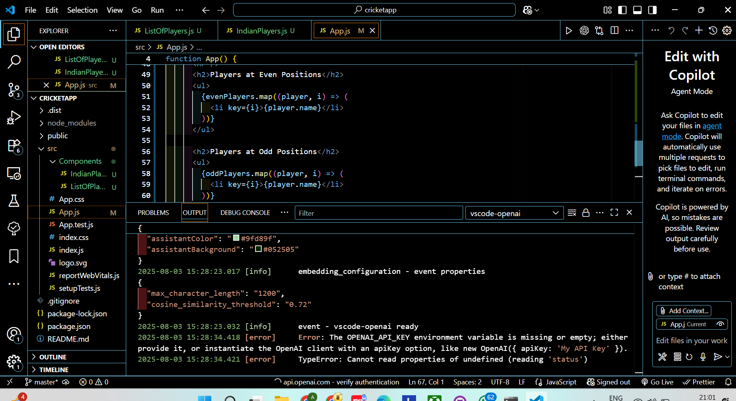
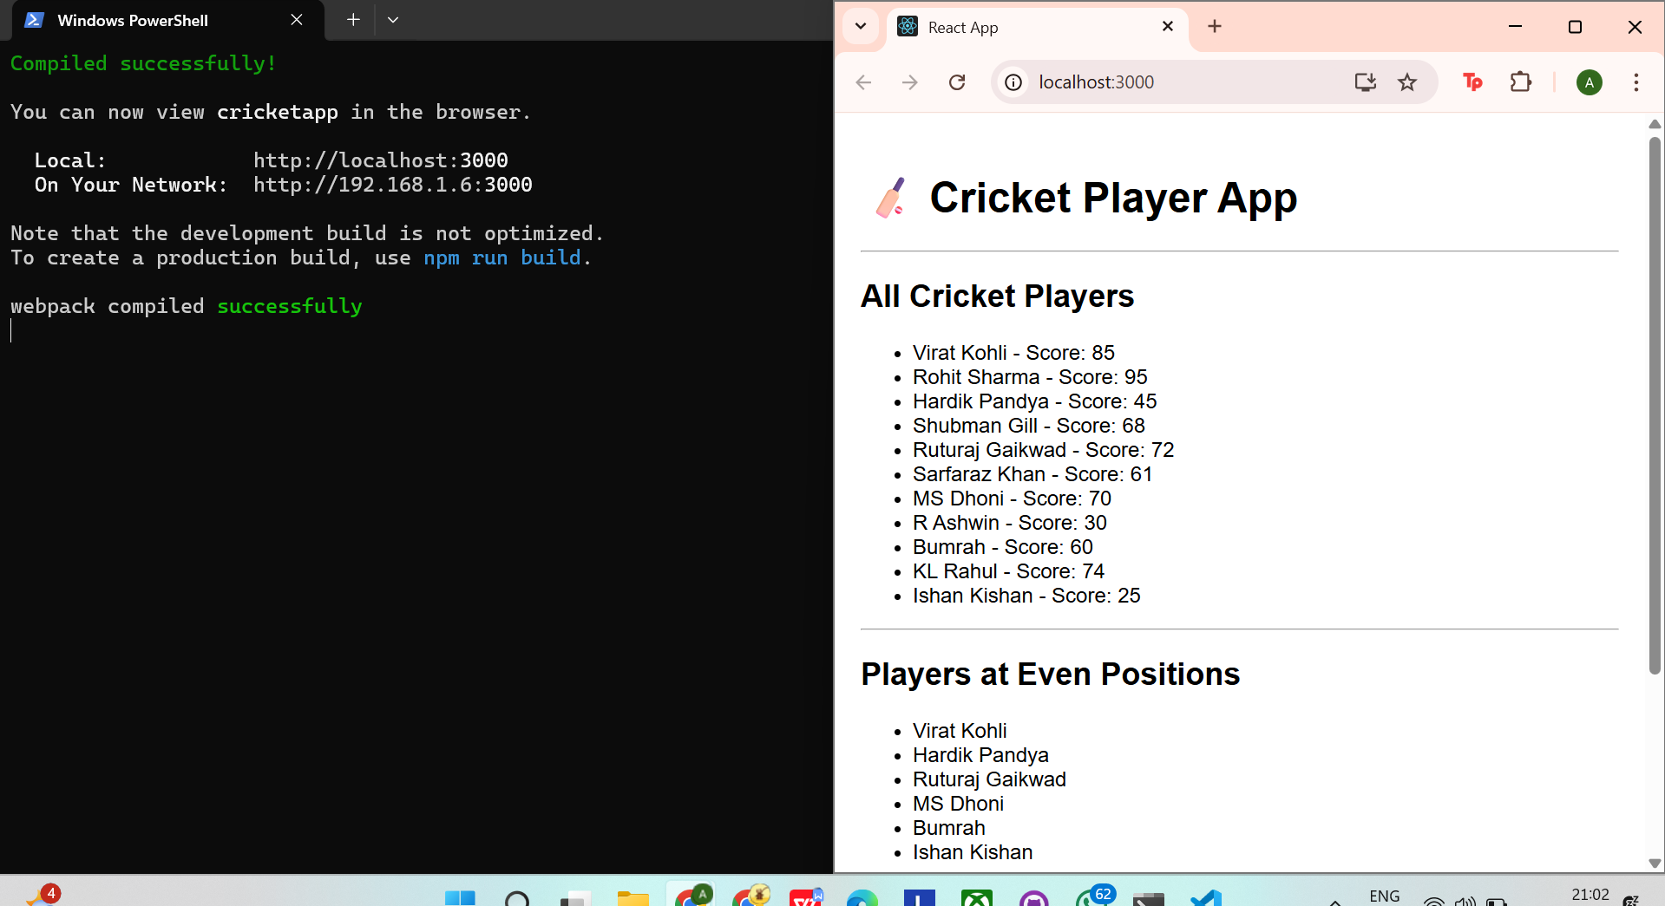
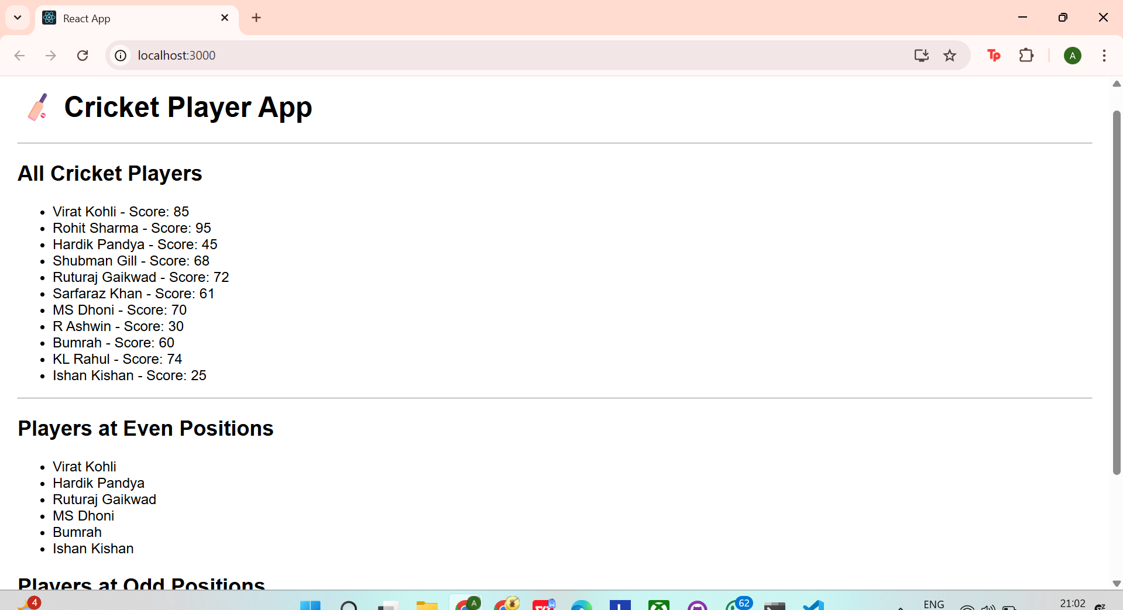

TASK - 10

src/Components/OfficeList.js
import React from 'react';
function OfficeList() {
const officeSpaces = [
{ name: "WeWork", rent: 85000, address: "MG Road, Bangalore" },
{ name: "Innov8", rent: 55000, address: "Connaught Place, Delhi" },
{ name: "91Springboard", rent: 72000, address: "Baner, Pune" },
{ name: "SmartWorks", rent: 40000, address: "Gachibowli, Hyderabad" },
];

return (
<div style={{ fontFamily: "Arial", padding: "20px" }}>
<h1>🏢 <strong>Office Space Rental App</strong></h1>
<ul style={{ listStyle: "none", padding: 0 }}>
{officeSpaces.map((office, index) => (
<li key={index} style={{ marginBottom: "20px" }}>
<h3>{office.name}</h3>
<p><strong>Address:</strong> {office.address}</p>
<p>
<strong>Rent:</strong>{" "}
<span
style={{
color: office.rent >= 60000 ? "green" : "red",
fontWeight: "bold"
}}
>
₹{office.rent}
</span>
</p>
<hr />
</li>
))}
</ul>
</div>
);
}
export default OfficeList;

src/App.js
import './App.css';import OfficeList from './Components/OfficeList';
function App() {
return (
<div className="App">
<OfficeList />
</div>
);
}
export default App;

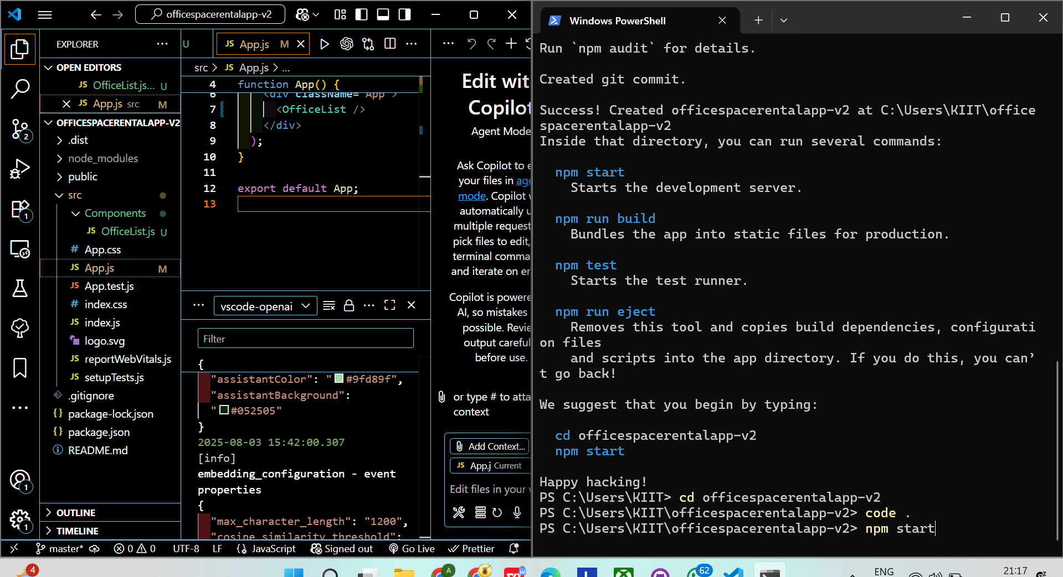

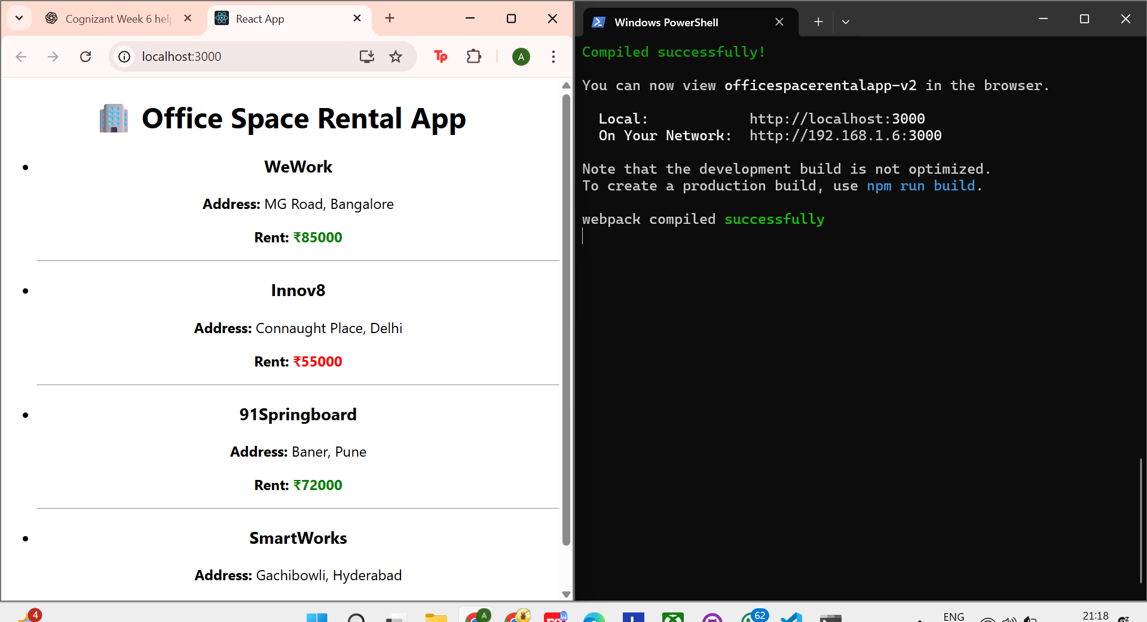

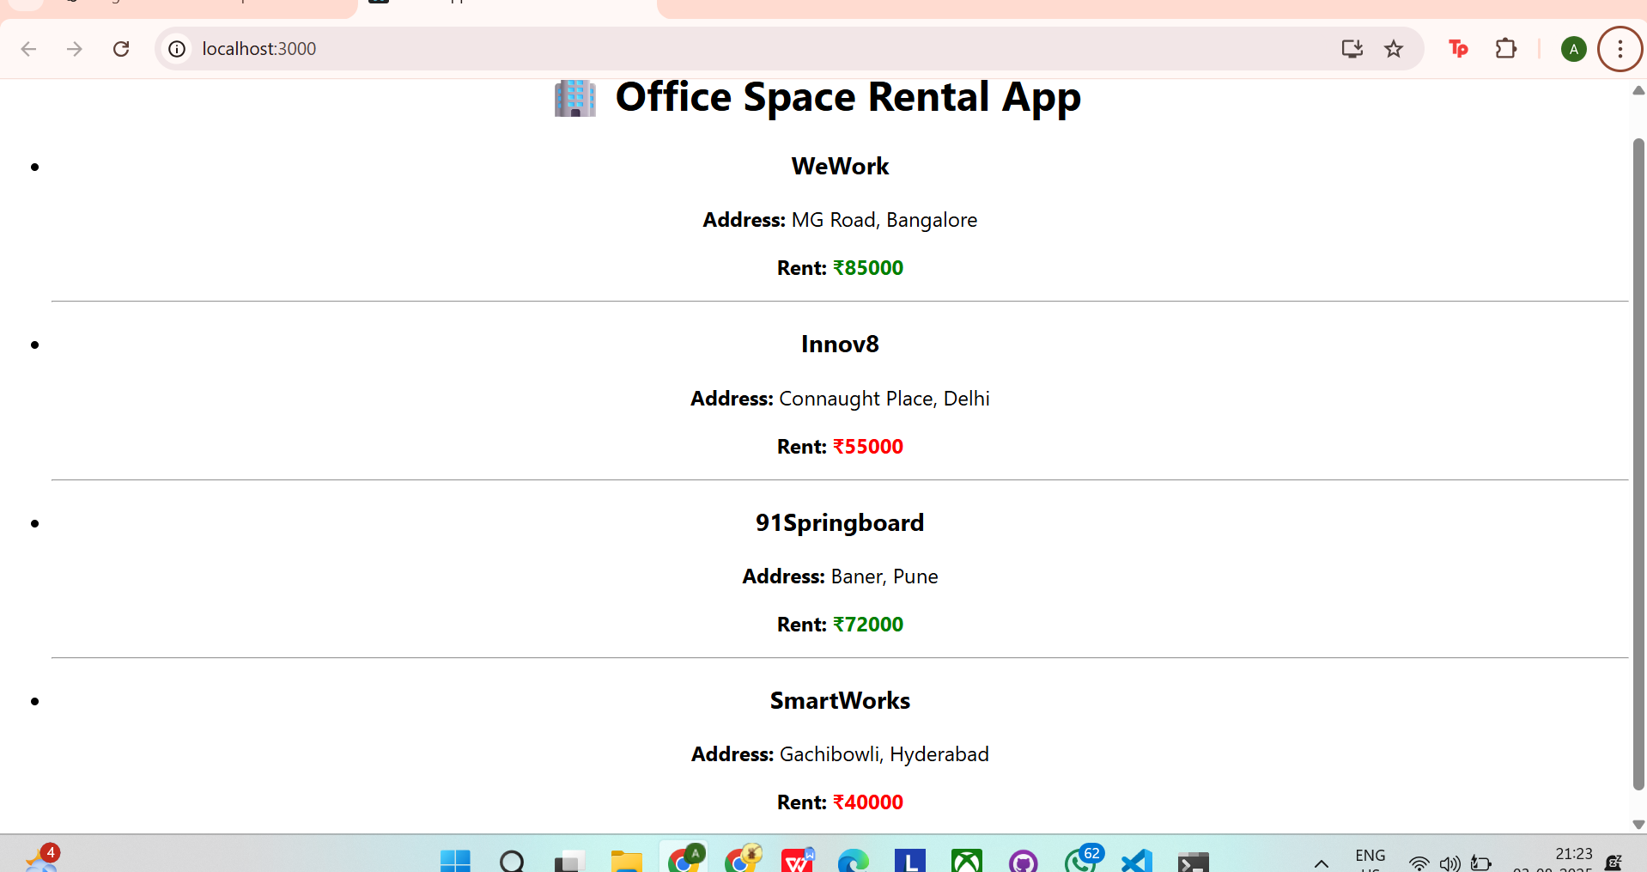

TASK - 11

src/Components/StudentForm.js

import React, { useState } from 'react';

function StudentForm() {
const [name, setName] = useState('');
const [school, setSchool] = useState('');
const [totalMarks, setTotalMarks] = useState('');
const [goalMarks, setGoalMarks] = useState('');
const [percentage, setPercentage] = useState(null);

const calculatePercentage = () => {
if (totalMarks && goalMarks && !isNaN(totalMarks) && !isNaN(goalMarks)) {
const result = (parseFloat(totalMarks) / parseFloat(goalMarks)) * 100;
setPercentage(result.toFixed(2));
} else {
setPercentage('Invalid Input');
}
};

return (
<div style={{ fontFamily: 'Arial', padding: '20px', textAlign: 'center' }}>
<h1>📘 Student Score Calculator</h1>
<input
type="text"
placeholder="Enter Name"
value={name}
onChange={(e) => setName(e.target.value)}
style={{ margin: '5px' }}
/>
<br />
<input
type="text"
placeholder="Enter School"
value={school}
onChange={(e) => setSchool(e.target.value)}
style={{ margin: '5px' }}
/>
<br />
<input
type="number"
placeholder="Enter Total Marks"
value={totalMarks}
onChange={(e) => setTotalMarks(e.target.value)}
style={{ margin: '5px' }}
/>
<br />
<input
type="number"
placeholder="Enter Goal Marks"
value={goalMarks}
onChange={(e) => setGoalMarks(e.target.value)}
style={{ margin: '5px' }}
/>
<br />
<button onClick={calculatePercentage} style={{ margin: '10px' }}>
Calculate Percentage
</button>

{percentage && (
<div>
<p><strong>Name:</strong> {name}</p>
<p><strong>School:</strong> {school}</p>
<p><strong>Percentage:</strong> {percentage}%</p>
</div>
)}
</div>
);
}

export default StudentForm;

src/App.js

import './App.css';
import StudentForm from './Components/StudentForm';

function App() {
return (
<div className="App">
<StudentForm />
</div>
);
}

export default App;

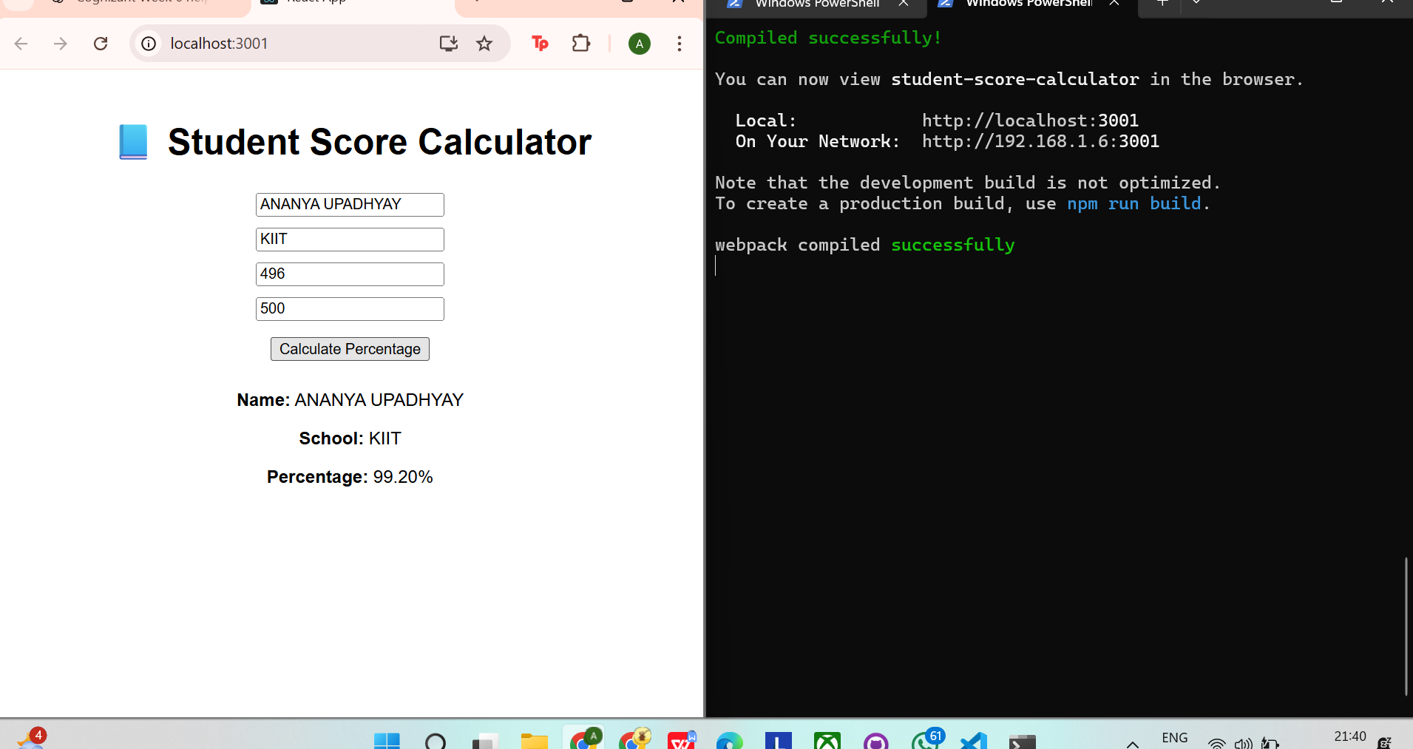
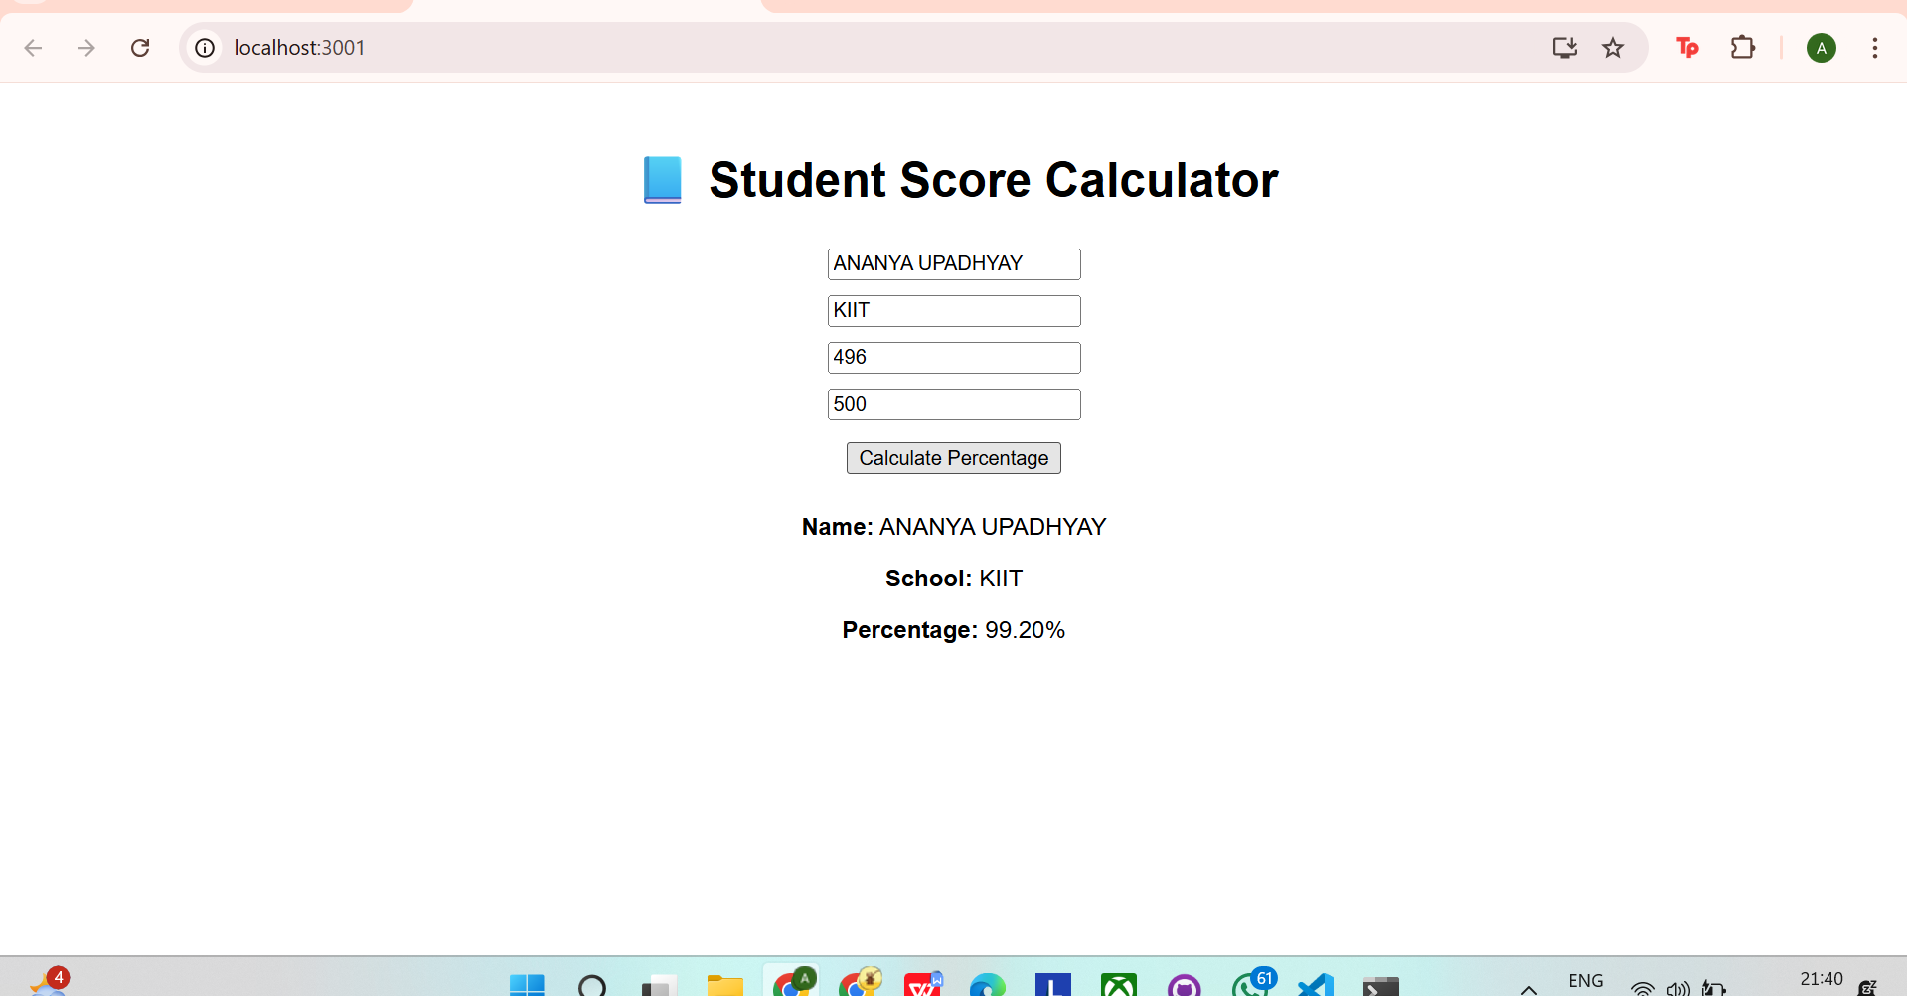

TASK - 12

App.js
import React, { useState } from 'react';import ProductList from './components/ProductList';import Cart from './components/Cart';import './App.css';
function App() {
const [cartItems, setCartItems] = useState([]);

const handleAddToCart = (product) => {
setCartItems([...cartItems, product]);
};

return (
<div className="App">
<h1>🛒 React Shopping Cart</h1>
<h3>Total Items in Cart: {cartItems.length}</h3>
<ProductList onAddToCart={handleAddToCart} />
<Cart cartItems={cartItems} />
</div>
);
}
export default App;

ProductList.js
import React from 'react';
const products = [
{ id: 1, name: 'Headphones', price: 1999 },
{ id: 2, name: 'Bluetooth Speaker', price: 2999 },
{ id: 3, name: 'Wireless Mouse', price: 799 },
];
function ProductList({ onAddToCart }) {
return (
<div>
<h2>🛍️ Available Products</h2>
<ul>
{products.map(product => (
<li key={product.id} style={{ marginBottom: '10px' }}>
<strong>{product.name}</strong> - ₹{product.price}
<button
style={{ marginLeft: '10px' }}
onClick={() => onAddToCart(product)}
>
Add to Cart
</button>
</li>
))}
</ul>
</div>
);
}
export default ProductList;

components/Cart.js
import React from 'react';
function Cart({ cartItems }) {
return (
<div>
<h2>🧾 Items in Cart</h2>
{cartItems.length === 0 ? (
<p>No items yet 😶</p>
) : (
<ul>
{cartItems.map((item, index) => (
<li key={index}>
{item.name} - ₹{item.price}
</li>
))}
</ul>
)}
</div>
);
}
export default Cart;

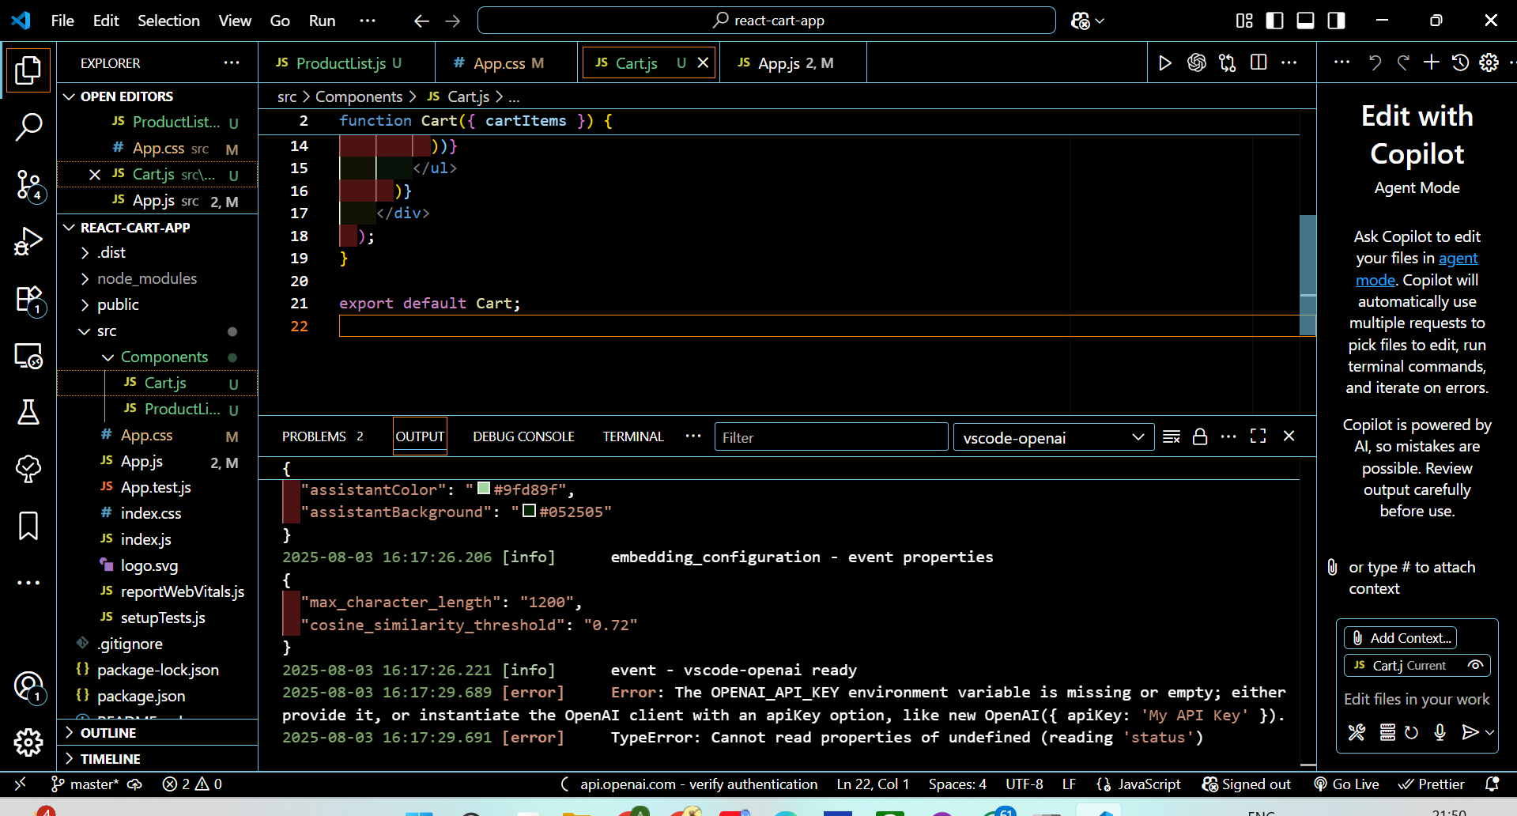
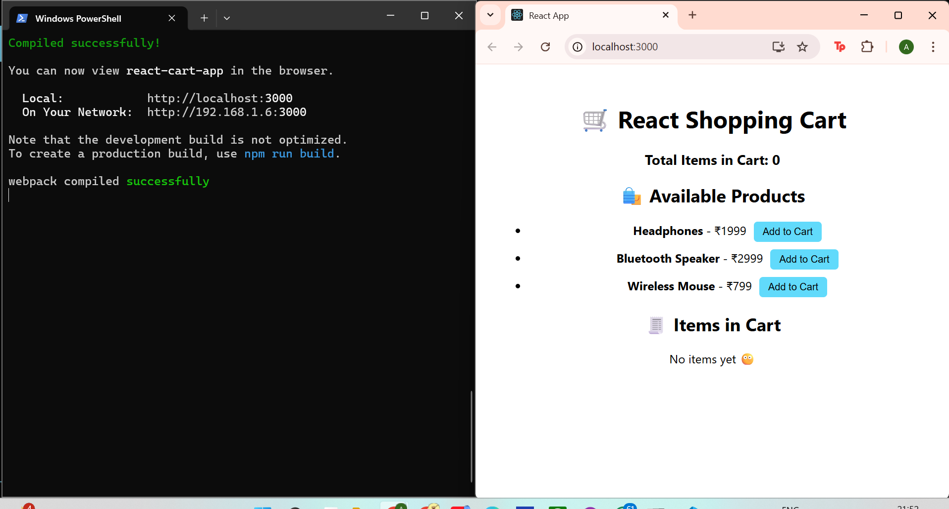
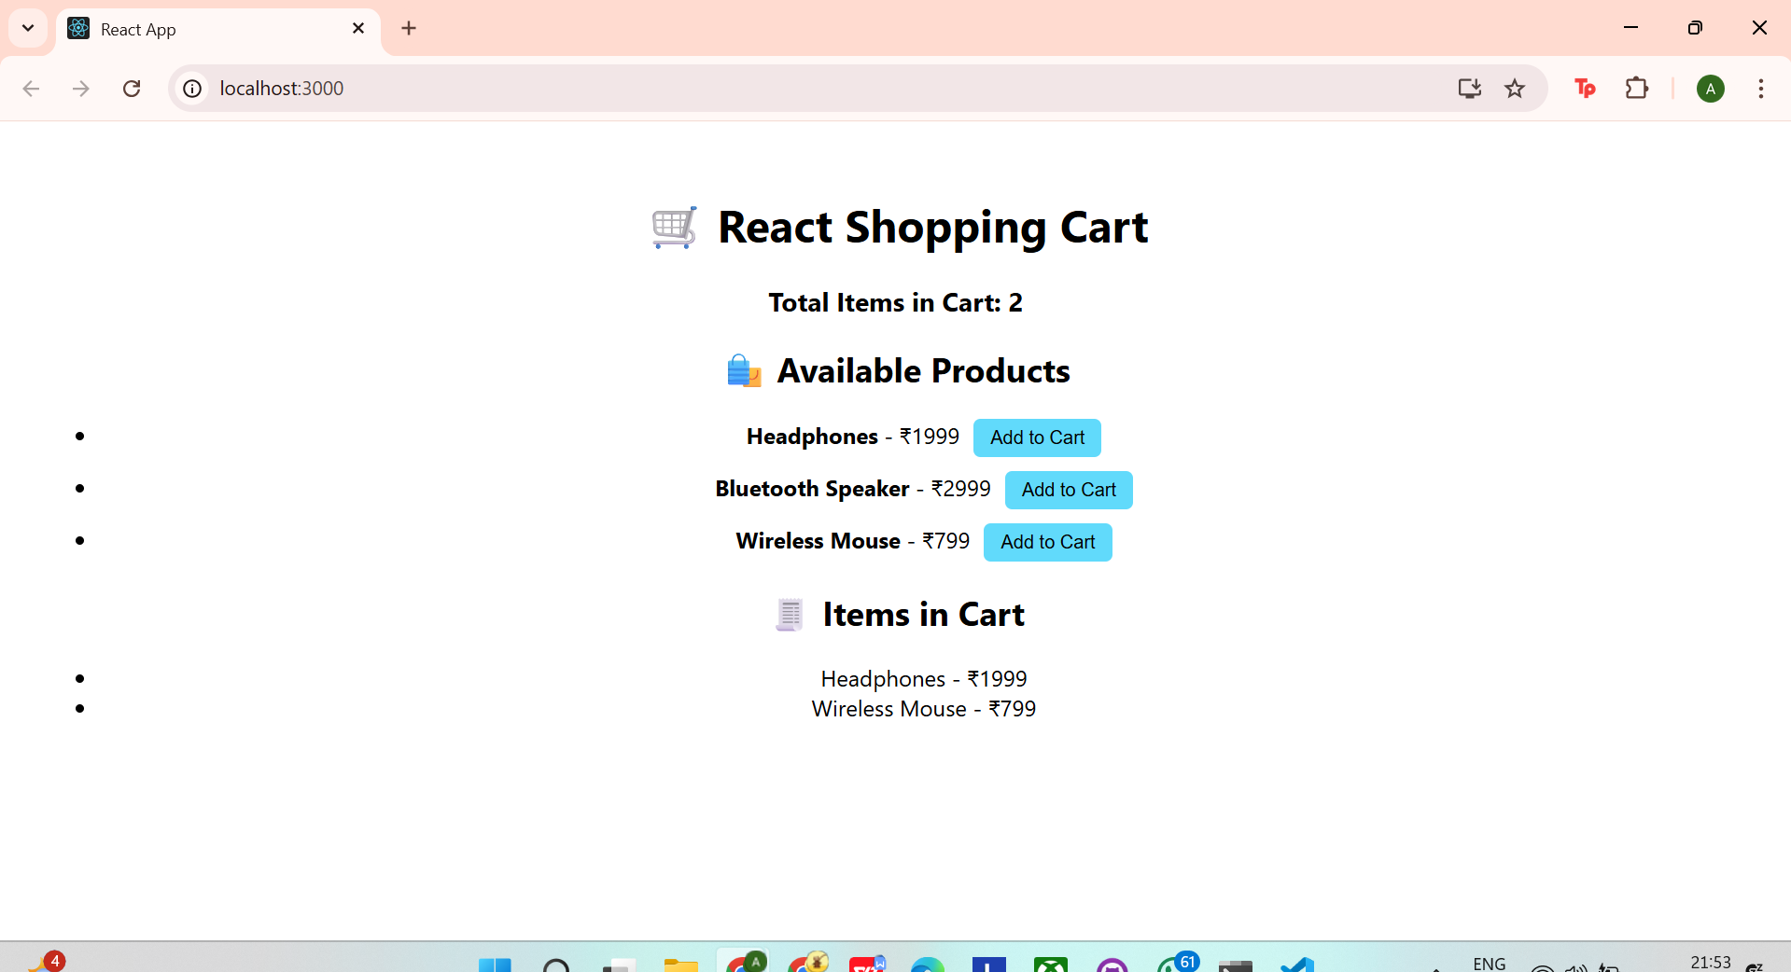

TASK - 13

App.js
import './App.css';import StudentProfileForm from './components/StudentProfileForm';
function App() {
return (
<div className="App">
<StudentProfileForm />
</div>
);
}
export default App;

StudentProfileForm.js
jsx
Copy code
import React, { useState } from 'react';
function StudentProfileForm() {
const [name, setName] = useState('');
const [age, setAge] = useState('');
const [grade, setGrade] = useState('');
const [city, setCity] = useState('');
const [submitted, setSubmitted] = useState(false);

const handleSubmit = (e) => {
e.preventDefault();
if (name && age && grade && city) {
setSubmitted(true);
} else {
alert('Please fill in all fields');
}
};

return (
<div style={{ textAlign: 'center', padding: '20px', fontFamily: 'Arial' }}>
<h1>🎓 Student Profile App</h1>
<form onSubmit={handleSubmit}>
<input
type="text"
placeholder="Enter Name"
value={name}
onChange={(e) => setName(e.target.value)}
style={{ margin: '5px' }}
/>
<br />
<input
type="number"
placeholder="Enter Age"
value={age}
onChange={(e) => setAge(e.target.value)}
style={{ margin: '5px' }}
/>
<br />
<input
type="text"
placeholder="Enter Grade"
value={grade}
onChange={(e) => setGrade(e.target.value)}
style={{ margin: '5px' }}
/>
<br />
<input
type="text"
placeholder="Enter City"
value={city}
onChange={(e) => setCity(e.target.value)}
style={{ margin: '5px' }}
/>
<br />
<button type="submit" style={{ margin: '10px' }}>Submit</button>
</form>

{submitted && (
<div style={{ marginTop: '20px' }}>
<h3>📋 Student Profile:</h3>
<p><strong>Name:</strong> {name}</p>
<p><strong>Age:</strong> {age}</p>
<p><strong>Grade:</strong> {grade}</p>
<p><strong>City:</strong> {city}</p>
</div>
)}
</div>
);
}
export default StudentProfileForm;
